**PABNA UNIVERSITY OF SCIENCE AND TECHNOLOGY**



**Faculty of Engineering & Technology**

**Department of Information and Communication Engineering**

**Course name : Signals and Systems**

**Course Code : ICE-2203**

**Assignment On:**

1. Explain the conditions for the existence of the Fourier transform.
2. Why does DFT produce both positive and negative frequencies?
3. What is the sampling theorem? Derive the Nyquist rate.
4. Define stability in terms of system response.

5. Properties of Fourier Transform.

Submitted By:

Even (Group-1)

Session:2021-22

2nd Year 2nd Semester

Department of ICE, PUST

Submitted To:

**Dr. Md. Imran Hossain**

Associate Professor

Department of Information and

Communication Engineering,

Pabna University of Science and Technology, Pabna

Date of Submission: 24/02/2025

Even Group-1:

Roll:

* 220604
* 220606
* 220608
* 220612
* 220614
* 220616
* 220618
* 220620
* 220622

1. Explain the conditions for the existence of the Fourier transform.

**Answer :**

The Fourier transform of a function x(t) is given by:

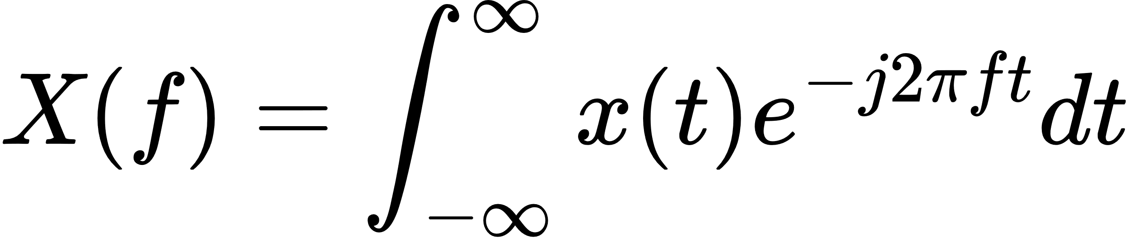

For this integral to exist and converge, certain conditions must be satisfied, known as **Dirichlet conditions**:

### a. Absolute Integrability

The function must be absolutely integrable over the entire time domain:



* This means that the total area under the magnitude of the function must be finite.
* Physically, this implies that the function has finite energy or power, which is necessary for meaningful frequency representation.

### b. Finite Number of Discontinuities

* x(t) can have discontinuities, but the number of these discontinuities should be finite in any finite interval.
* The discontinuities must not be infinite jumps (e.g., Dirac delta functions are not allowed).

### c. Finite Number of Maxima and Minima

* In any finite interval, the function should have a finite number of maxima and minima.
* This ensures that the function is not oscillating infinitely in a finite region, which would make the integral divergent.

### d. Piecewise Continuity

* The function should be piecewise continuous, which means it can have discontinuities, but between these points, it must be continuous.
* Each piece should be finite and well-behaved.

### Example :

The function :

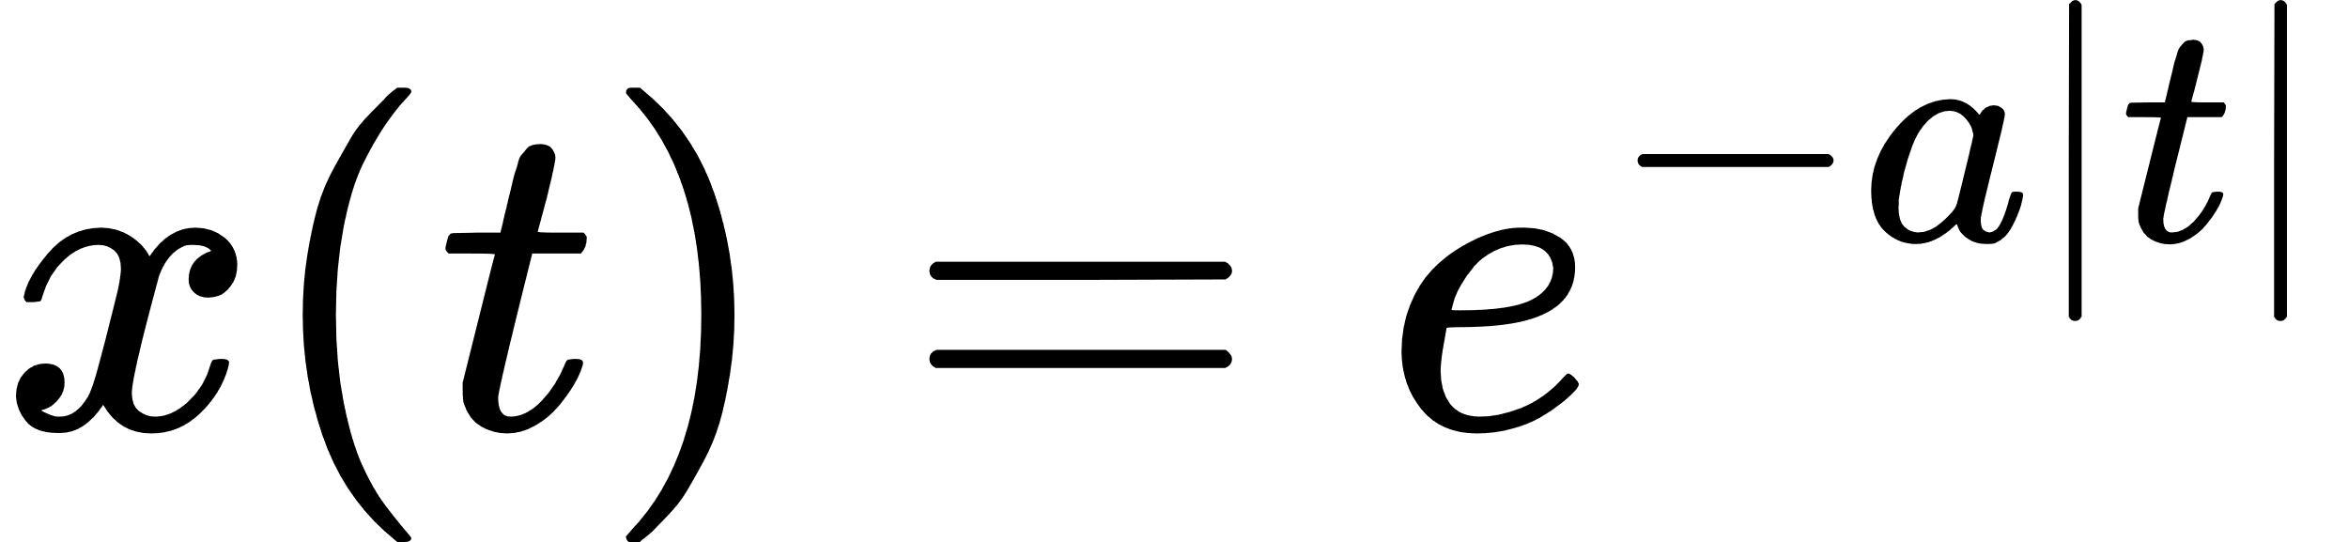

where a>0, satisfies all these conditions:

* It is absolutely integrable because its area converges.
* It is continuous everywhere.
* It has no discontinuities or infinite oscillations.  
  Therefore, its Fourier transform exists.

1. Why does DFT produce both positive and negative frequencies?

**Answer :**

The DFT of a discrete-time signal x[n] is given by:

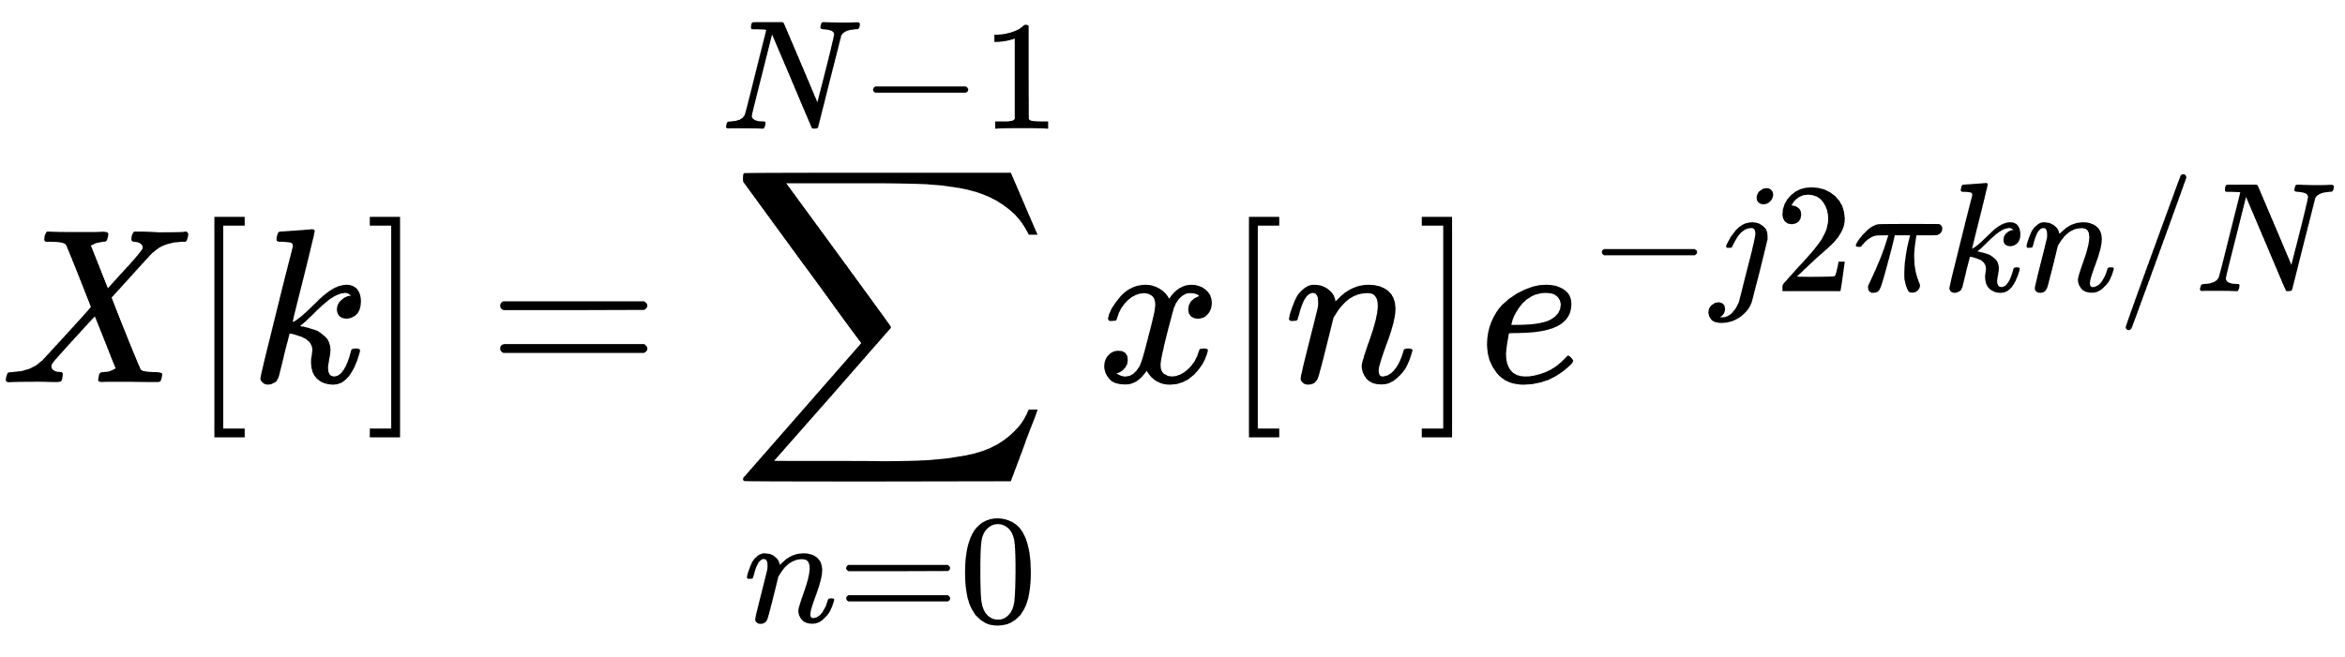

* Here, k represents the frequency index, and N is the total number of samples.
* The resulting X[k] is periodic with period N.
* The DFT uses complex exponentials 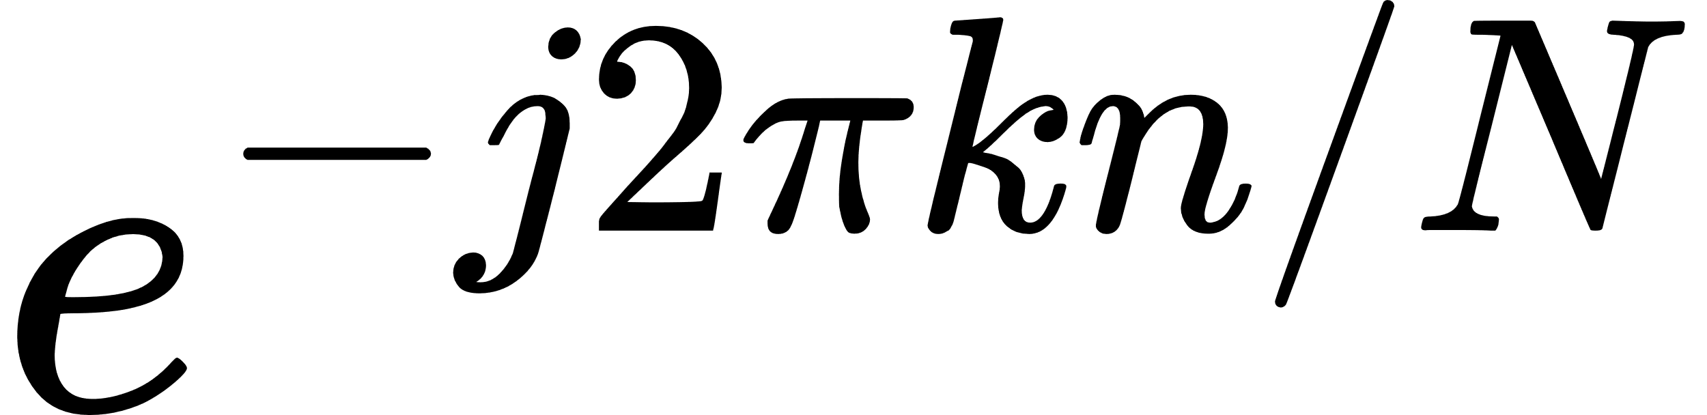 as basis functions, which can be expanded using Euler's formula:

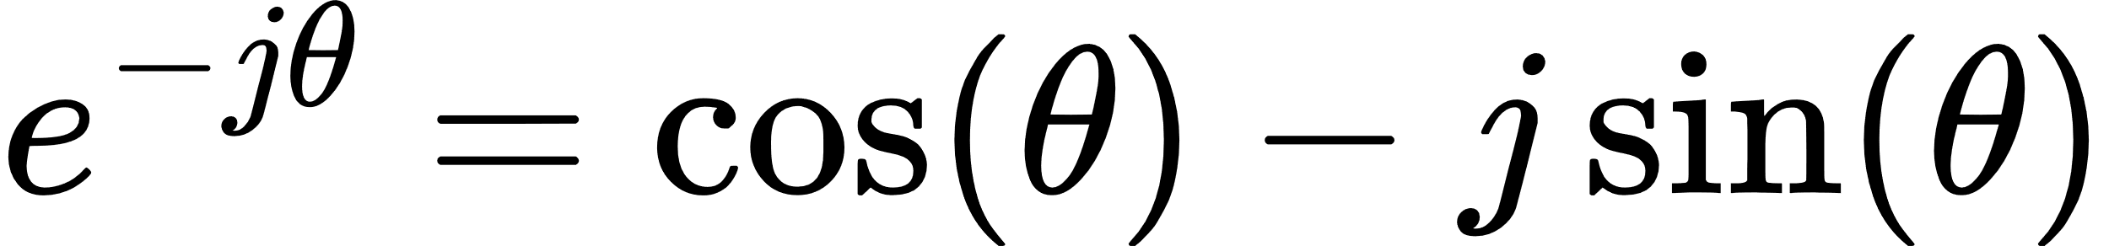

* This complex form inherently represents both positive and negative frequencies:
  + Positive frequencies correspond to counterclockwise rotation in the complex plane.
  + Negative frequencies correspond to clockwise rotation.

### Symmetry in DFT :

* Due to the periodic nature of the DFT, the frequency components are symmetric. Specifically:

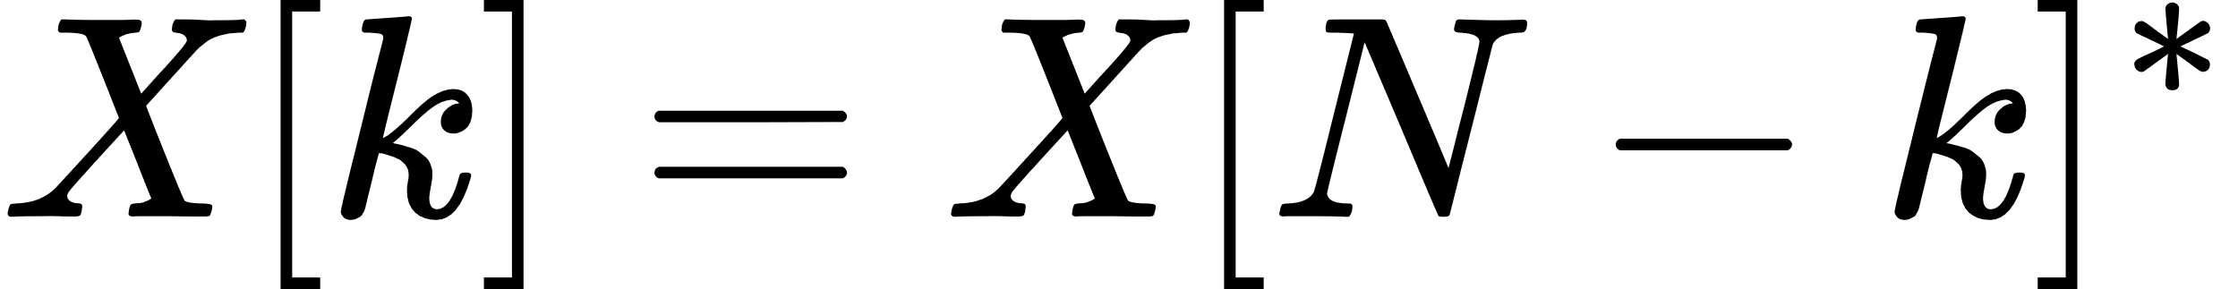

* This conjugate symmetry shows that negative frequencies are just the mirror images of positive frequencies.
* In practice, the negative frequencies are not "real" but represent phase information, helping to fully reconstruct the time-domain signal.

### Example :

For a real-valued input x[n] , the DFT exhibits conjugate symmetry:

* X[1] corresponds to a positive frequency.
* X[N−1] corresponds to a negative frequency of the same magnitude but opposite phase.

1. What is the sampling theorem? Derive the Nyquist rate.

**Answer :**

The Sampling Theorem, also known as **Nyquist-Shannon Sampling Theorem**, states:

* **A band-limited continuous-time signal** x(t)**, having no frequency components higher than** fmax **, can be completely represented by its samples and perfectly reconstructed if the sampling rate is at least twice the highest frequency component.**
* Mathematically, if X(f) is the Fourier transform of x(t) and X(f)=0 for ∣f∣ > fmax , then the sampling frequency fs must satisfy:

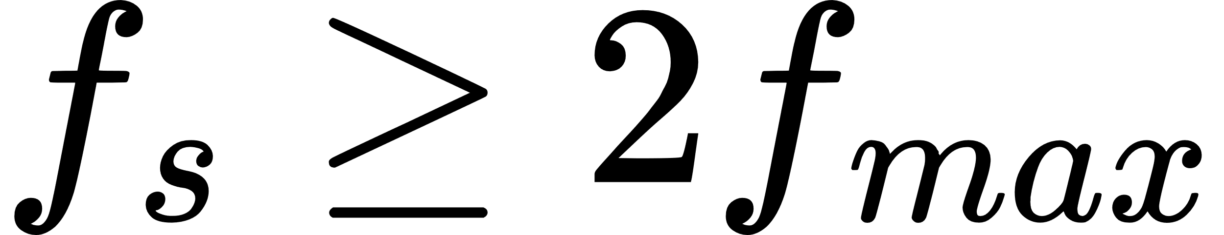

This minimum sampling rate is known as the **Nyquist Rate**.

### Derivation of Nyquist Rate :

1. ***Fourier Transform of the Continuous Signal:***  
   Consider a band-limited signal x(t) with Fourier transform X(f), which is nonzero only in the range −fmax to fmax.
2. ***Sampling Process****:*  
   The sampled signal is:

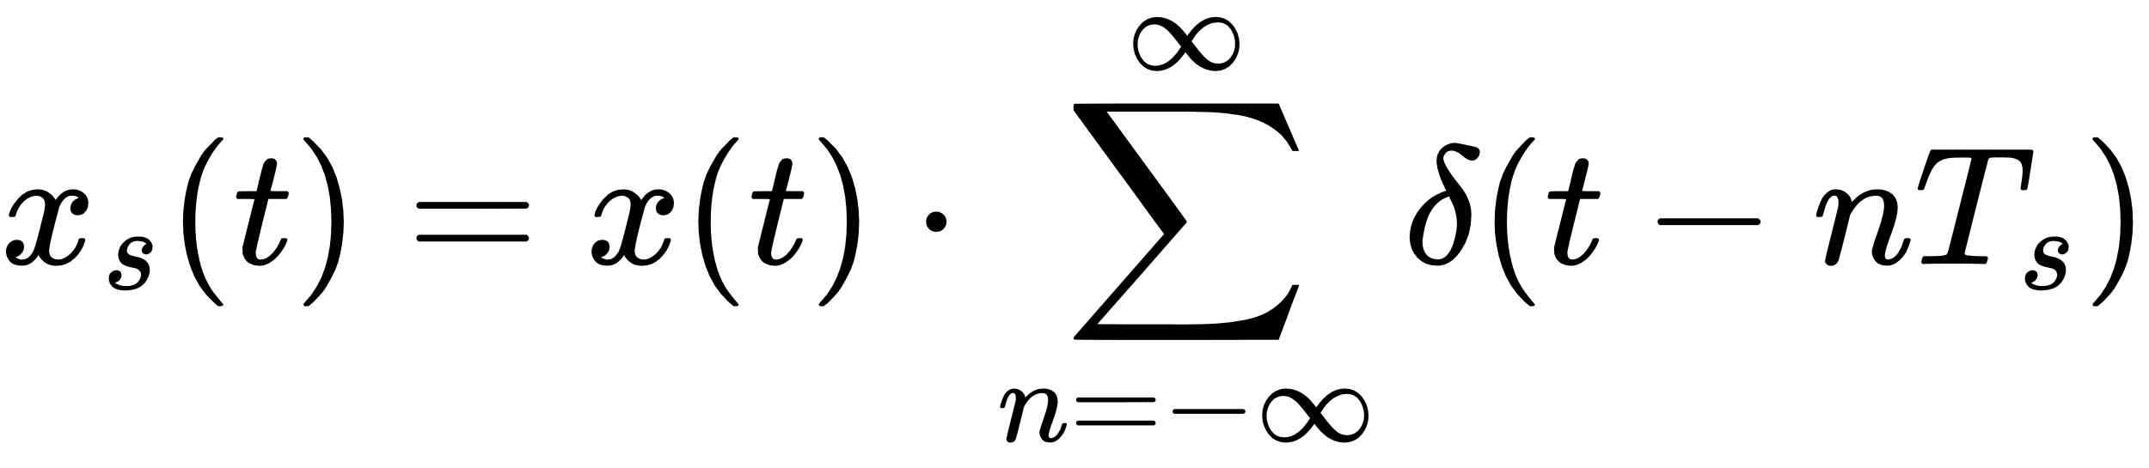

Where ,

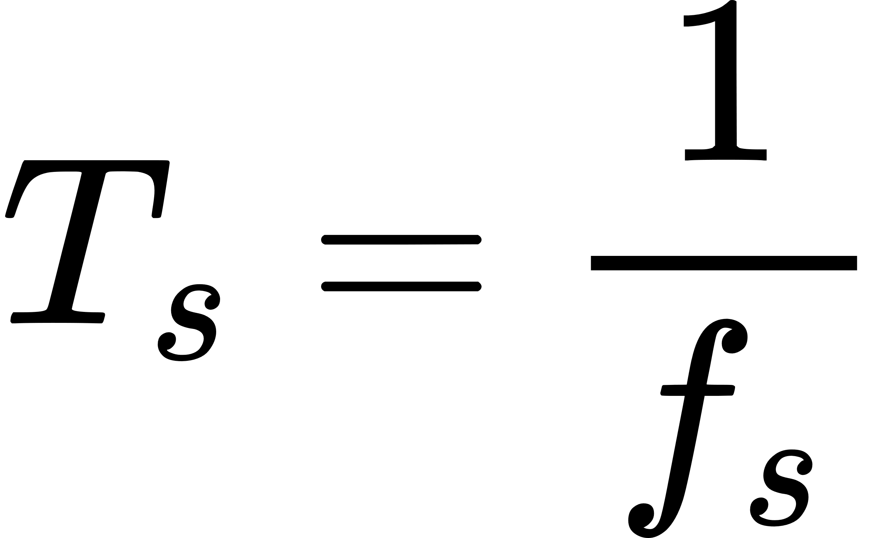​ is the sampling interval.

1. ***Fourier Transform of Sampled Signal****:*  
   The Fourier transform of the sampled signal is:

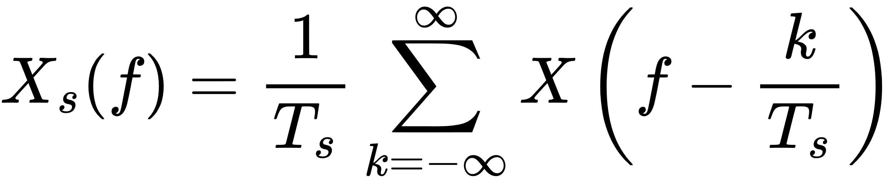

This shows that the spectrum of x(t) repeats periodically with period fs.

1. ***Avoiding Aliasing****:*  
   To avoid overlap of these repeated spectra (aliasing), we require:

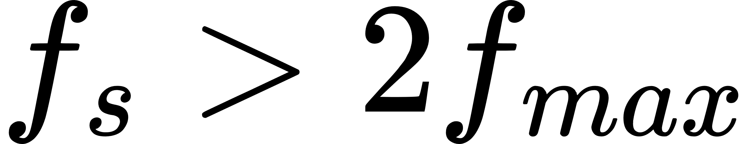

The minimum value for fs that satisfies this inequality is called the **Nyquist Rate**:

### wps

### Example :

If the maximum frequency of a signal is 5 kHz, then the Nyquist rate is:

fs ≥ 2×5 = 10 kHz

4. Define stability in terms of system response.

**Answer :**

A system is **stable** if its output remains bounded for any bounded input. Mathematically:

* If the input x(t) is bounded, i.e., ∣x(t)∣ < Mx for some finite Mx, then the output y(t) should also be bounded, i.e., ∣y(t)∣ < My​ for some finite My.

Or,



where Mx and My are finite constants.

For **Linear Time-Invariant (LTI)** systems, stability is determined using the **Impulse Response** h(t):

* The system is stable if:

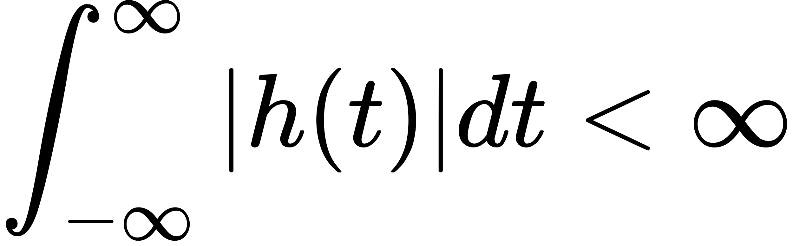

* This means the total energy of the impulse response should be finite.

### Example :

The system with impulse response h(t) = e-at is:

* Stable if a > 0 because the integral converges.
* Unstable if a ≤ 0 because the integral diverges.

**5. Properties of Fourier Transform**

The Fourier Transform has several important properties:

**(i) Linearity**

$$F\left[c_{1}x_{1}\left(t\right)+c_{2}x_{2}\left(t\right)\right]=\int_{-∞}^{∞}{\left[c_{1}x_{1}\left(t\right)+c_{2}x_{2}\left(t\right)\right]e^{-jωt}dt}$$

$=c_{1}\int_{-∞}^{∞}{x_{1}\left(t\right)e^{-jωt}dt}+c_{2}\int_{-∞}^{∞}{x_{2}\left(t\right)e^{-jωt}dt}$

$=c_{1}X_{1}\left(ω\right)+c_{2}X_{2}\left(ω\right)$

Scaling and addition in the time domain correspond to the same operations in the frequency domain.

**(ii) Time Shifting**

$$\text{If }x\left(t\right)↔X\left(ω\right),\text{ then }x\left(t-c\right)↔X\left(ω\right)e^{-jωc}\text{ for any constant }c.$$

$$Proof:[F\left[x\left(t-c\right)\right]=\int_{-∞}^{∞}{x\left(t-c\right)e^{-jωt}dt}$$

$$=\int_{-∞}^{∞}{x\left(t\right)e^{-jω\left(t+c\right)}dt}$$

$$=e^{-jωc}\int_{-∞}^{∞}{x\left(t\right)e^{-jωt}dt}$$

$$=X\left(ω\right)e^{-jωc}.$$

A shift in the time domain introduces a phase shift in the frequency domain.

**(iii) Frequency Shifting**

$$\text{If }x\left(t\right)↔X\left(ω\right),\text{ then }x\left(t\right)e^{jω_{0}t}↔X\left(ω-ω_{0}\right)\text{ for any }real ω_{0}.$$

$$Proof:[F\left[x\left(t\right)e^{jω_{0}t}\right]$$

$$=\int_{-∞}^{∞}{x\left(t\right)e^{jω_{0}t}e^{-jωt}dt}$$

$$=\int_{-∞}^{∞}{x\left(t\right)e^{-j\left(ω-ω_{0}\right)t}dt}$$

$$=X\left(ω-ω_{0}\right).$$

Multiplying by an exponential shifts the spectrum.

**(iv) Time Revising**

$$F\left[f\left(-t\right)\right]=\int_{-∞}^{∞}{f\left(-t\right)e^{-jωt}dt}$$

$=\int_{t=-∞}^{t=∞}{f\left(-t\right)e^{-jωt}dt}$

$=\int_{t=-∞}^{t=∞}{f\left(t\right)e^{jωt}d\left(-t\right)}=\int_{t=∞}^{t=-∞}{f\left(t\right)e^{jωt}d\left(-t\right)}$

$=-\int_{t=-∞}^{t=∞}{f\left(t\right)e^{jωt}dt}$

$$=\int_{-∞}^{∞}{f\left(t\right)e^{jωt}dt}=F\left(-jω\right)$$

Scaling in time compresses or expands the frequency spectrum.

**(v) Modulation Theorem**

$$If(x\left(t\right)↔X\left(ω\right)),then[x\left(t\right)\cos\left(ω_{0}t\right)↔\frac{1}{2}\left[X\left(ω+ω_{0}\right)+X\left(ω-ω_{0}\right)\right].$$

$$F\left[x\left(t\right)\cos\left(ω_{0}t\right)\right]=F\left[\frac{1}{2}x\left(t\right)\left(e^{jω_{0}t}+e^{-jω_{0}t}\right)\right]$$

$$=\frac{1}{2}F\left[x\left(t\right)e^{jω_{0}t}\right]+\frac{1}{2}F\left[x\left(t\right)e^{-jω_{0}t}\right]$$

$$=\frac{1}{2}\left[X\left(ω-ω_{0}\right)+X\left(ω+ω_{0}\right)\right].$$

Convolution in the time domain corresponds to multiplication in the frequency domain.

**(vi) Convolution Theorem**

$$If(x\left(t\right)↔X\left(ω\right))and(v\left(t\right)↔V\left(ω\right)),then[x\left(t\right)⋆v\left(t\right)↔X\left(ω\right)V\left(ω\right).$$

$$Proof:[F\left[x\left(t\right)⋆v\left(t\right)\right]=\int_{-∞}^{∞}{\left[x\left(t\right)⋆v\left(t\right)\right]e^{-jωt}dt}$$

$$=\int_{-∞}^{∞}{\left(\int_{-∞}^{∞}{x\left(λ\right)v\left(t-λ\right)dλ}\right)e^{-jωt}dt}$$

$$=\int_{-∞}^{∞}{x\left(λ\right)\left(\int_{-∞}^{∞}{v\left(t-λ\right)e^{-jωt}dt}\right)d}$$

$$=\int_{-∞}^{∞}{x\left(λ\right)V\left(ω\right)e^{-jωλ}d}$$

$$=V\left(ω\right)\int_{-∞}^{∞}{x\left(λ\right)e^{-jωλ}dλ}=X\left(ω\right)V\left(ω\right).$$